Jacob Vaught
Transmission Message: You study hard and USC rocks!
Code for decomposing message:
clc; clear; close all;

% Load data and define constants
load('IQdata_FMT.mat');
rho = 0.2;
M = 32;
S = 10;
fsample = 5e6; % Unified sampling frequency variable
Fspacing = 30e3;
Nup = floor(fsample / (Fspacing / (1 + rho)));

% Timing and signal parameters
t = linspace(0, (length(IQdata_FMT)-1) / fsample, length(IQdata_FMT)); % Simplified time vector creation
filter_length = length(IQdata_FMT)-3; % Adjusted for fixed SNup value
rrc_t = linspace(-(filter_length - 1) / (2 * Nup), (filter_length - 1) / (2 * Nup), filter_length);
norm_rrc = rrc(rho, rrc_t) / norm(rrc(rho, rrc_t)); % Normalized RRC filter

% Signal processing
sym = zeros(M, S); % Initialize symbol matrix
for k = 0:M-1
x = conv(IQdata_FMT .* exp(-1j*2*pi*k*Fspacing*t), norm_rrc);
downsampled = downsample(x, Nup);
sym(k+1, :) = round(real(downsampled(46:45+S))); % Symbol extraction
end

% Symbol to string conversion
bits = (sym + 1) / 2;
binaryChar = char(bits + '0');
transposedBinaryChar = reshape(binaryChar, 8, [])'; % Preparing for binary to decimal conversion
decimalValues = bin2dec(transposedBinaryChar);
str = char(decimalValues); % Decoding message
disp(str'); % Display the decoded string, transposed so it is on one line

- Data Preparation and Parameter Definition:
  - The modulated data, stored as IQdata_FMT, is loaded into the MATLAB environment. Essential parameters including the roll-off factor (rho), total number of channels (M), symbols per channel (S), unified sampling frequency (fsample), and frequency spacing (Fspacing) are defined. These parameters are critical in setting up the environment for proper signal processing and decoding.
- Signal Processing Setup:
  - A time vector t is constructed to match the duration of the IQdata_FMT, facilitating accurate time-domain representation. An RRC (Root-Raised-Cosine) filter, characterized by the specified roll-off factor, is generated and normalized, serving as the basis for signal shaping and matched filtering.
- Demodulation and Symbol Extraction:
  - The script iterates over each channel, applying demodulation techniques to shift channel spectra to baseband, followed by matched filtering using the normalized RRC filter. After convolution, the signals are down-sampled to match the symbol rate, and a predefined set of symbols(10 symbols) is extracted from each channel, forming the basis for message reconstruction.
- Message Decoding:
  - The extracted symbols are converted from bipolar to binary format, then into ASCII characters. This conversion entails adjusting symbol values, mapping them into binary digits, organizing these digits into bytes, and finally translating each byte into its corresponding ASCII character, resulting in the decoded message.

Following is the IQ data from the FMT and ODFM messages.
The plots illustrate distinct differences between Frequency Modulated Techniques (FMT) and Orthogonal Frequency Division Multiplexing (OFDM) signals. The FMT signals, displayed in blue, show notable amplitude fluctuations and prominent spikes, indicating transitions between different symbols or the effects of specific filtering processes like Root Raised Cosine filters. These characteristics are typical of FMT systems, where various frequency channels are employed for transmission, leading to significant variation across the signal's duration.
In contrast, the OFDM signals, represented in cyan and yellow for their I and Q branches respectively, exhibit more uniform amplitude levels with occasional large spikes, likely corresponding to symbol boundaries or cyclic prefix insertions, a feature used in OFDM to combat intersymbol interference. The sample index range for OFDM is notably shorter than that of FMT, showing the differences in sampling rates.
Overall, while FMT signals display pronounced amplitude variations and longer sample durations, OFDM signals maintain a consistent level of variation, indicative of their ability to handle multipath effects and maintain signal integrity across different transmission channels.
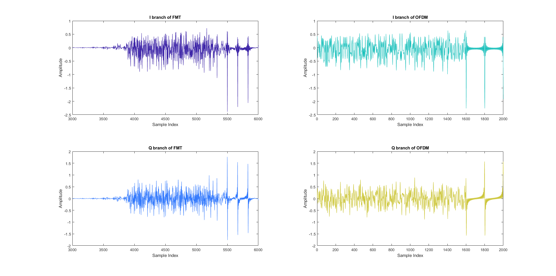
clc; clear; close all;

% Load data
load('IQdata_FMT.mat');
load('IQdata_OFDM.mat');

% Extract I and Q components for FMT and OFDM
I_FMT = real(IQdata_FMT);
Q_FMT = imag(IQdata_FMT);
I_OFDM = real(IQdata_OFDM);
Q_OFDM = imag(IQdata_OFDM);

% Define parula colors
numColors = 5; % Number of plots
parulaColors = parula(numColors); % Generate color matrix

% Plotting
figure;
subplot(2,2,1);
plot(I_FMT, 'Color', parulaColors(1,:)); % Use first parula color
title('I branch of FMT');
xlabel('Sample Index');
ylabel('Amplitude');
xlim([3000,6000])

subplot(2,2,3);
plot(Q_FMT, 'Color', parulaColors(2,:)); % Use second parula color
title('Q branch of FMT');
xlabel('Sample Index');
ylabel('Amplitude');
xlim([3000,6000])

subplot(2,2,2);
plot(I_OFDM, 'Color', parulaColors(3,:)); % Use third parula color
title('I branch of OFDM');
xlabel('Sample Index');
ylabel('Amplitude');

subplot(2,2,4);
plot(Q_OFDM, 'Color', parulaColors(4,:)); % Use fourth parula color
title('Q branch of OFDM');
xlabel('Sample Index');
ylabel('Amplitude');

The OFDM method takes up less bandwidth. $BW=32*30=960kHz for OFDM$
$$BW=30*1.2*32=1152kHz for FMT$$
Although this doesn’t line up exactly with the PSD graphs, the relationship is shown clearly.
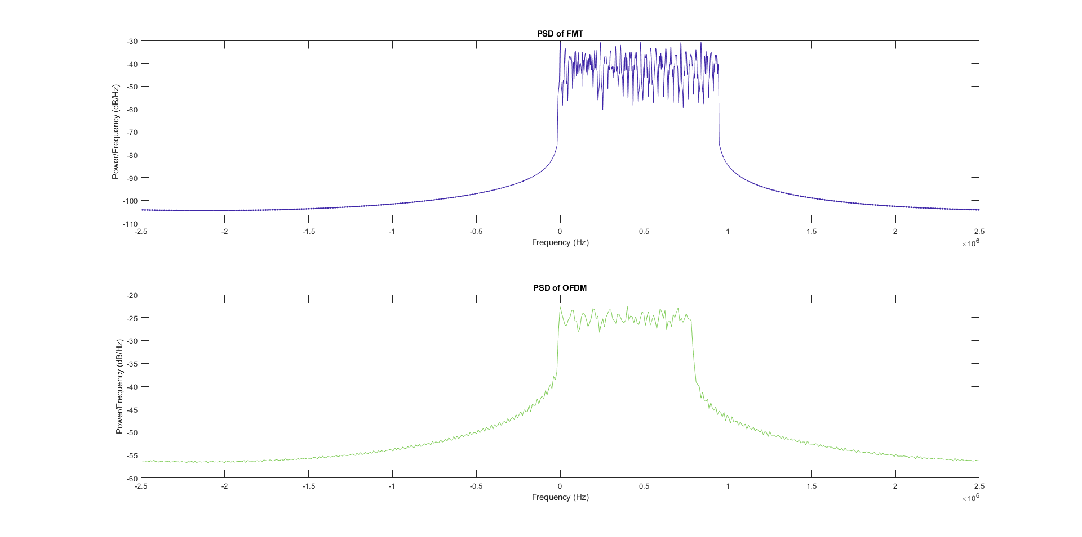
clc; clear; close all;

% Load data
load('IQdata_FMT.mat');
load('IQdata_OFDM.mat');

% Define sampling frequency
Fs = 5e6; % Sampling frequency in Hz

% Define parula colors
numColors = 4; % Adjusted for PSD plots
parulaColors = parula(numColors); % Generate color matrix

% Plotting PSD
figure;

% PSD for FMT data
subplot(2,1,1);
[pxx, f] = pwelch(IQdata_FMT, [], [], [], Fs, 'centered', 'power');
plot(f, 10*log10(pxx), 'Color', parulaColors(1,:)); % Use first parula color for FMT
title('PSD of FMT');
xlabel('Frequency (Hz)');
ylabel('Power/Frequency (dB/Hz)');

% PSD for OFDM data
subplot(2,1,2);
[pxx, f] = pwelch(IQdata_OFDM, [], [], [], 6e6, 'centered', 'power');
plot(f, 10*log10(pxx), 'Color', parulaColors(3,:)); % Use third parula color for OFDM
title('PSD of OFDM');
xlabel('Frequency (Hz)');
ylabel('Power/Frequency (dB/Hz)');

